**1.Facebook Gathers Companies to Back Cryptocurrency Launch.**



Facebook, Inc. ([FB](https://www.investopedia.com/markets/quote?tvwidgetsymbol=fb)) has big plans to unveil its new platform cryptocurrency next week, with a launch slated for next year, according to a detailed report by the [**Wall Street Journal**](https://www.wsj.com/articles/facebooks-new-cryptocurrency-gets-big-backers-11560463312). Users of the social media platform will be able to send the digital coin, called **Libra**, to one another, and they will also be able to use it to make purchases both through Facebook and across the internet more broadly.

KEY TAKEAWAYS

* Libra is the much-hyped digital currency proposed by Facebook to be used within its online ecosystem.
* Libra is intended to be a 'stablecoin' that is pegged to a basket of global currencies including the US dollar, Euro, and Yen.
* Heavyweights in the payments space such as Mastercard and PayPal, among others, have signed on as corporate partners and sponsors of the Libra project.
* Regulators in the EU and US, however, have raised concerns and red flags over Libra's potential risks and may squash its release.

# 2.New study allows brain and artificial neurons to link up over the web.

# Image result for neurons link up over web

During the study, researchers based at the University of Padova in Italy cultivated rat neurons in their laboratory, whilst partners from the University of Zurich and ETH Zurich created artificial neurons on Silicon microchips. The virtual laboratory was brought together via an elaborate setupcontrolling nanoelectronic synapses developed at the University of Southampton. These synaptic devices are known as memristors.

The Southampton based researchers captured spiking events being sent over the internet from the biological neurons in Italy and then distributed them to the memristive synapses. Responses were then sent onward to the artificial neurons in Zurich also in the form of spiking activity. The process simultaneously works in reverse too; from Zurich to Padova. Thus, artificial and biological neurons were able to communicate bidirectionally and in real time.

## [3.Blockchain is emerging from the shadows and making its way into a murky future. Don’t count it out.](https://www.nytimes.com/spotlight/dealbook-special-section)

[[](https://www.nytimes.com/spotlight/dealbook-special-section)](https://www.nytimes.com/spotlight/dealbook-special-section)

You’ve probably heard that the blockchain is a technology that is going to change the world — it is the backbone of Bitcoin, the now infamous cryptocurrency. You might even have heard someone trying to explain blockchain by describing it as a “[trusted distributed ledger.”](http://www.finra.org/sites/default/files/2017_BC_Byte.pdf)

Meanwhile, Fortune 500 companies are investing billions in the blockchain. IBM has a whole division focused on blockchain, as do the consultancies Accenture and PwC. Jamie Dimon, JPMorgan Chase’s chief executive, has dismissed Bitcoin, but says “the blockchain is real.”

The blockchain is ultimately about solving society’s ultimate challenge: trust. Or rather, lack of trust. Blockchain is about using technology to create a shared sense of trust by a group of disparate participants.

The biggest question is whether the hundreds of projects like Decentraland, where individuals are using real money to buy virtual property, will end well or badly — and whether that experience will ultimately instill or undermine trust in this emerging technology.

# 4.Neo3 Exception Handling Mechanism

# https://miro.medium.com/max/800/1*_ojSkzPMuUKnmQGyeYnp1g.jpeg

# What’s Exception?

Exceptions are abnormal events that occur while the program is running such as divide by 0 overflow, array index over bounds, nonexistent contract call, etc.

A well-designed program should provide methods for handling exceptions when they occur, so that the program does not block or produce unexpected results because of the occurrence of exceptions. For example, if a payment is insufficient or fails, we need to resume other operations.

# 5. Exploring Server-Driven UI

## “A new way to build reactive apps with native UI”



Native apps are still the first choice for businesses that want to expand at scale and reach out to millions based on their UI and performance. This statement might be controversial for many of the people out there, but we’re not going to discuss which platform is best. Instead, we’re going to learn how to grab more control over what you’re showing in the app using server-driven UI.

**What Is Server-Driven UI?**

Server-driven UI is when the API tells the client what components to render and with what content. This can be implemented in all three major platforms: Android, iOS, and the web. In my opinion, this type of development makes native apps more reactive and controllable.

6. Remote Development with Pycharm

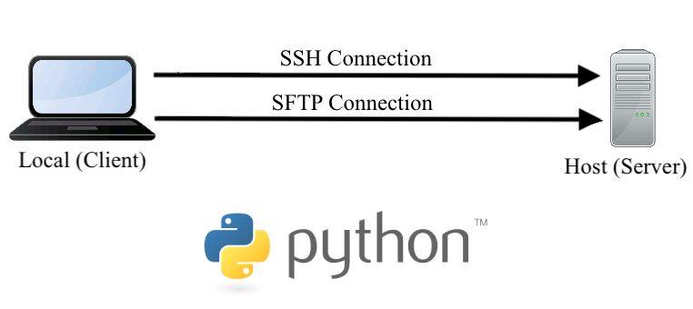

[Pycharm](https://www.jetbrains.com/pycharm/) is a great IDE — complete with features that promote [productive programming](https://www.jetbrains.com/pycharm/features/), a community devoted to sharing clever [plug-ins](https://plugins.jetbrains.com/pycharm), and, my personal favorite trait, [Professional licenses are free to students](https://www.jetbrains.com/community/education/#students). With this, [JetBrains toolbox](https://www.jetbrains.com/toolbox-app/) with its many IDEs (one for most modern computing language) is available to students free of charge (no strings attached).

**WORKING REMOTELY VIA PYCHARM**

With the [**Coronavirus**](https://www.who.int/health-topics/coronavirus) now an international concern, a vast percentage of professionals must work remotely. As someone set up an iMac (i.e., local machine) to work in sync with a PC running Ubuntu (i.e., remote host), the next step is to configure PyCharm to edit locally and run remotely. There are many reasons one may want to do this — our motivation is to easily deploy jobs to the remote host with GPUs.

7 .How Do Companies Use Big Data Analytics in Real World?

The most valuable item for any company in modern times is data! Companies can work much more efficiently by analyzing large amounts of data and making business decisions on that basis. This means that **Big Data Analytics** is the current path to profit!



[**Big Data Analytics**](https://www.geeksforgeeks.org/data-analytics-and-its-type/) is much more objective than the older methods and companies can make the correct business decisions using data insights.

So let’s see the different ways companies can use Big Data Analytics in the real world to improve their performance and become even more successful (and rich!) with time.

### 1. Companies use Big Data Analytics to Increase Customer Retention

An example of a company that uses Big Data Analytics to Increase Customer Retention is **Amazon**

### 2. Companies use Big Data Analytics to create Marketing Campaigns.

An example of a company that uses Big Data Analytics to create Marketing Campaigns is **Netflix**.

### 3. Companies use Big Data Analytics for Risk Management

An example of a company that uses Big Data Analytics for Risk Management is **Starbucks**

### 4. Companies use Big Data Analytics for Supply Chain Handling.

An example of a company that uses Big Data Analytics for Supply Chain Handling is **PepsiCo**.

### 5. Companies use Big Data Analytics for Product Creation

An example of a company that uses Big Data Analytics for Product Creation is **Burberry**, a British luxury fashion house.

## [Announcing TensorFlow Quantum: An Open Source Library for Quantum Machine Learning](http://ai.googleblog.com/2020/03/announcing-tensorflow-quantum-open.html)

“Nature isn’t classical, damnit, so if you want to make a simulation of nature, you’d better make it quantum mechanical.” — Physicist [Richard Feynman](https://www.nobelprize.org/prizes/physics/1965/feynman/biographical/)

Today, in collaboration with the [University of Waterloo](https://uwaterloo.ca/), [X](https://x.company/), and [Volkswagen](https://www.volkswagenag.com/en/news/2018/06/volkswagen-tests-quantum-computing-in-battery-research.html), release of [TensorFlow Quantum](https://www.tensorflow.org/quantum) (TFQ), an open-source library for the rapid prototyping of quantum ML models. TFQ provides the tools necessary for bringing the quantum computing and machine learning research communities together to control and model natural or artificial quantum systems; e.g. [Noisy Intermediate Scale Quantum](https://arxiv.org/abs/1801.00862) (NISQ) processors with ~50 - 100 qubits.

[](https://1.bp.blogspot.com/-Fh22J53FPQs/XmKe2PJG78I/AAAAAAAAFZs/YOD35UMCxcwQbPQaRM8BSWU7niY2I5LoQCLcBGAsYHQ/s1600/image1.jpg)

Under the hood, TFQ integrates [Cirq](https://ai.googleblog.com/2018/07/announcing-cirq-open-source-framework.html) with [TensorFlow](https://www.tensorflow.org/), and offers high-level abstractions for the design and implementation of both discriminative and generative quantum-classical models by providing quantum computing primitives compatible with existing TensorFlow APIs, along with high-performance quantum circuit simulators.  
  
**What is a Quantum ML Model?**  
A quantum model has the ability to represent and generalize data with a quantum mechanical origin. However, to understand quantum models, two concepts must be introduced - quantum data and hybrid quantum-classical models.  
**Quantum data** exhibits [superposition](https://en.wikipedia.org/wiki/Quantum_superposition) and [entanglement](https://en.wikipedia.org/wiki/Quantum_entanglement), leading to joint probability distributions that could require an exponential amount of classical computational resources to represent or store.  
The second concept to introduce is**hybrid quantum-classical models**.

**How TFQ works**  
TFQ allows researchers to construct quantum datasets, quantum models, and classical control parameters as tensors in a single computational graph. The outcome of quantum measurements, leading to classical probabilistic events, is obtained by [TensorFlow Ops](https://www.tensorflow.org/guide/create_op). Training can be done using standard Keras functions..

# Dimensionality Reduction in Data Mining

# Image result for data mining

Big data is the large scale of data sets that have multi-level variables and that grow really fast. Volume is the most important aspect of big data. Extremely big size of data in big data forms multidimensional datasets. Having multiple dimensions for the in a large data set makes the job of analyzing those or looking for any kind of patterns in the data really hard.

Dimensionality reduction is the process of reducing the number of random variables or attributes under consideration

## Techniques of dimensionality reduction

Dimensionality reduction is accomplished based on either **feature selection** or **feature extraction**. Feature selection is based on omitting those features from the available measurements which do not contribute to class separability..

## Feature selection techniques.

## As a stand-alone task, feature selection can be unsupervised (e.g. Variance Thresholds) or supervised (e.g. Genetic Algorithms). You can also combine multiple methods if needed.

## Feature extraction techniques

Feature extraction is for creating a new, smaller set of features that still captures most of the useful information. This can come as supervised(e.g. LDA) and unsupervised(e.g. PCA) methods.

**Microsoft buys JavaScript developer platform npm; plans to integrate it with GitHub**

Microsoft is acquiring npm, a major JavaScript-developer platform officials announced on 16th march.GitHub has signed an agreement to acquire npm

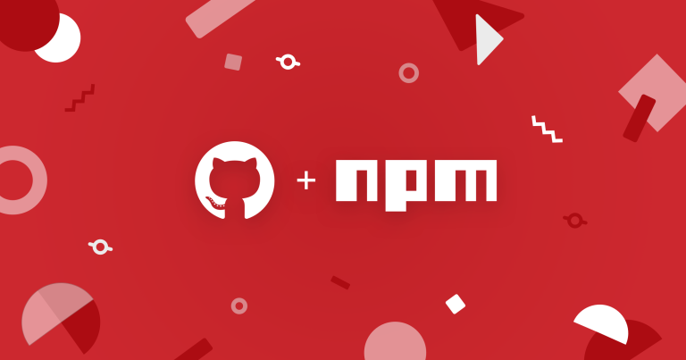

npm is a critical part of the JavaScript world. The work of the npm team over the last 10 years, and the contributions of hundreds of thousands of open source developers and maintainers, have made npm home to over 1.3 million packages with 75 billion downloads a month. Together, they’ve helped JavaScript become the largest developer ecosystem in the world.

For the millions of developers who use the public npm registry every day, npm will always be available and always be free. The focus after the deal closes will be to:

**Invest in the registry infrastructure and platform.** The JavaScript ecosystem is massive and growing quickly. It needs a rock-solid registry. We will make the investments necessary to ensure that npm is fast, reliable, and scalable.

**Improve the core experience**. Work to improve the everyday experience of developers and maintainers, and support the great work already started on the npm v7 CLI, which will remain free and open source. Some bigger features that we’re excited about are Workspaces and improvements to the publishing and multi-factor authentication experience.

**Engage with the community**.Actively engage with the JavaScript community to get your ideas and help us define the future of npm.

Databases also getting the full DevOps treatment, survey shows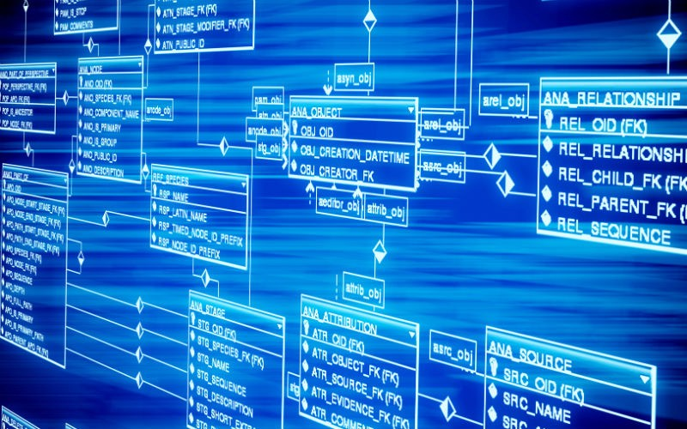

'Databases are recognized as another code deployment which can and should be managed, tested, automated, and improved with the same robust, reliable methodologies applied to application code'

DevOps isn't just for application deployments, it also applies to database development. DataOps is a variation which encourages automating the flow of data through enterprises, from source to storage. At the same time, DevOps -- which focuses on the flow of application delivery and deployment -- is increasingly being applied to databases, which are very large, sophisticated applications in their own right.

This conclusion is validated by Redgate's survey of 2,000 developers, which finds a rise in the number of DevOps deployments for databases, with almost half of respondents reporting they deploy database changes to production weekly or more frequently.

A majority, 68%, are in some phase of DevOps adoption across the board. About one in five, 18%, say they have adopted DevOps "across all projects," up from 15% a year ago. Forty-six percent of respondents are performing some form of database deployment automation. Managers within larger enterprises are bullish on database DevOps: more than 60% believe they will be moving from traditional database deployments to fully automated deployments can be achieved in a year or less.